**Viewing Results**

*This chapter describes the different ways in which the results of an analysis as well as the basic network input data can be viewed. These include different map views, graphs, tables, and special reports.*

## **Viewing Results on the Map:**

There are several ways in which database values and results of a simulation can be viewed directly on the Network Map:

* For the current settings on the Map Browser, the nodes and links of the map will be coloured according to the colour- coding used in the Map Legends. The map’s colouring will be updated as a new time period is selected in the Browser.
* When the Flyover Map Labelling program preference is selected, moving the mouse over any node or link will display its ID label and the value of the current viewing parameter for that node or link in a hint-style box.
* ID labels and viewing parameter values can be displayed next to all nodes and/or links by selecting the appropriate options on the Notation page of the Map Options dialog form.
* Nodes or links meeting a specific criterion can be identified by submitting a Map Query.
* You can animate the display of results on the network map either forward or backward in time by using the Animation buttons on the Map Browser. Animation is only available when a node or link viewing parameter is a computed value.
* The map can be printed, copied to the Windows clipboard, or saved as a DXF file or Windows metafile.

**Submitting a Map Query:**

A Map Query identifies nodes or links on the network map that meet a specific criterion. To submit a map query:

1. Select a time period in which to query the map from the Map Browser.
2. Select **View >> Query** or click image116 on the Map Toolbar.
3. Fill in the following information in the Query dialog form that appears:
   * Select whether to search for Nodes or Links
   * Select a parameter to compare against
   * Select **Above**, **Below,** or **Equal To**
   * Enter a value to compare against
4. Click the **Submit** button. The objects that meet the criterion will be highlighted on the map.
5. As a new time period is selected in the Browser, the query results are automatically updated.

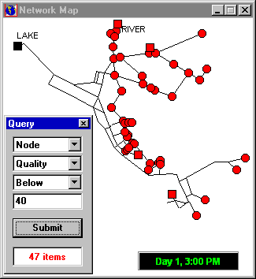

## **Viewing Results with a Graph:**

## Analysis results, as well as some design parameters, can be viewed using several different types of graphs. Graphs can be printed, copied to the Windows clipboard, or saved as a data file or Windows metafile.

|  |  |  |
| --- | --- | --- |
| **TYPE OF PLOT** | **DESCRIPTION** | **APPLIES TO** |
| Time Series Plot | Plots value versus time | Specific nodes or links over all time periods |
| Profile Plot | Plots value versus distance | A list of nodes at a specific time |
| Contour Plot | Shows regions of the map where values fall within specific intervals | All nodes at a specific time |
| Frequency Plot | Plots value versus fraction of objects at or below the value | All nodes or links at a specific time |
| System Flow | Plots total system production and consumption versus time | Water demand for all nodes over all time periods |

Types of Graphs Available to View Results

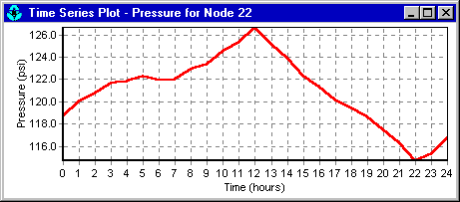 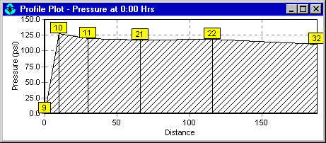

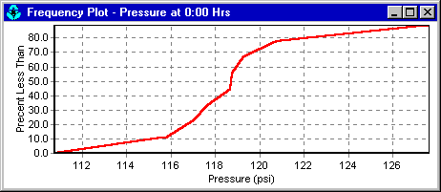 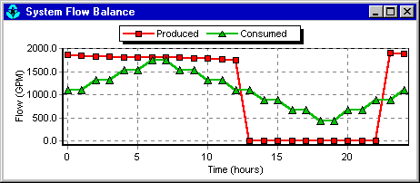

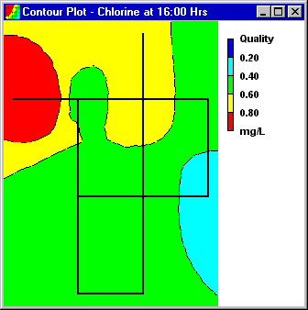

To create a graph:

1. Select **Report >> Graph** or click image117 on the Standard Toolbar.
2. Fill in the choices on the Graph Selection dialog box that appears.
3. Click **OK** to create the graph.

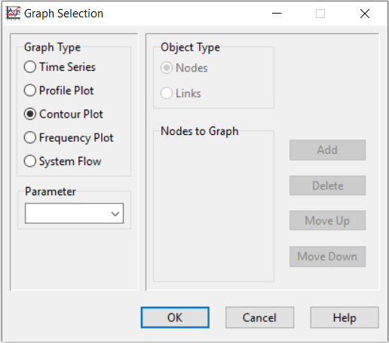

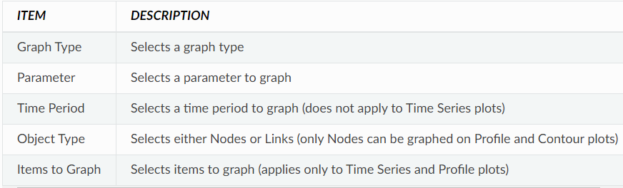

Time Series plots and Profile plots require one or more objects be selected for plotting. To select items into the Graph Selection dialog for plotting:

1. Select the object (node or link) either on the Network Map or on the Data Browser.
2. Click the **Add** button on the Graph Selection dialog to add the selected item to the list.

To customize the appearance of a graph:

1. Make the graph the active window (click on its title bar).
2. Select **Report >> Options**, or click image124 on the Standard Toolbar, or right-click on the graph.
3. For a Time Series, Profile, Frequency or System Flow plot, use the resulting Graph Options dialog to customize the graph’s appearance.
4. For a Contour plot use the resulting Contour Options dialog to customize the plot.

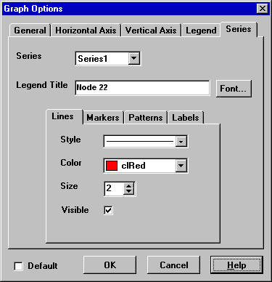

The Graph Options dialog form is used to customize the appearance of an X-Y graph. To use the dialog box:

1. Select from among the five tabbed pages that cover the following categories of options:
   * General
   * Horizontal Axis
   * Vertical Axis
   * Legend
   * Series
2. Check the **Default** box if you wish to use the current settings as defaults for all new graphs as well.
3. Select **OK** to accept your selections.

Graph Options General Tab

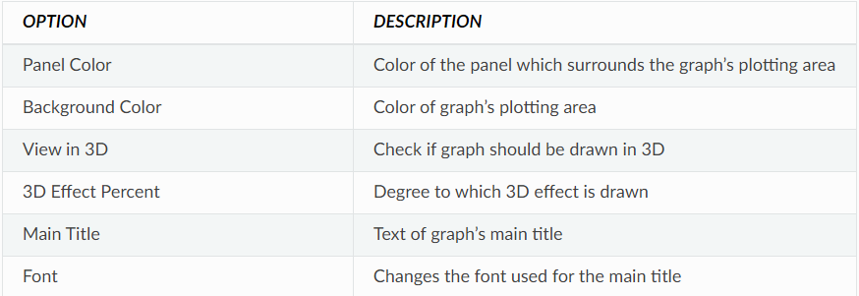

Graph Options Horizontal and Vertical Axis Tabs

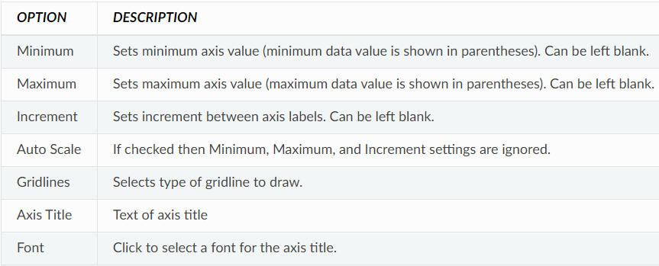

Graph Options Legend Tab

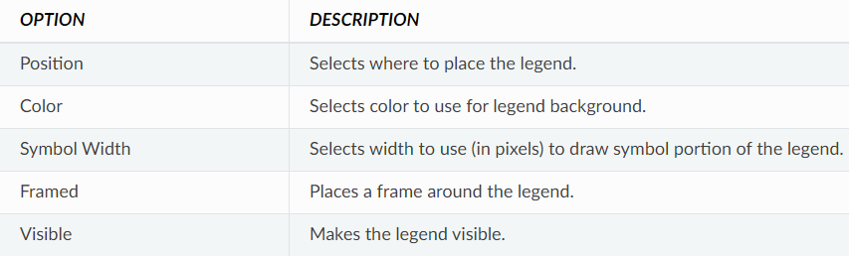

The Series tab of the Graph Options dialog controls how individual data series (or curves) are displayed on a graph. To use this page:

* Select a data series to work with from the Series combo box.
* Edit the title used to identify this series in the legend.
* Click the Font button to change the font used for the legend. (Other legend properties are selected on the Legend page of the dialog.)
* Select a property of the data series you would like to modify. The choices are:
  + Lines
  + Markers
  + Patterns
  + Labels

(Not all properties are available for some types of graphs.)

Graph Options Series Tab

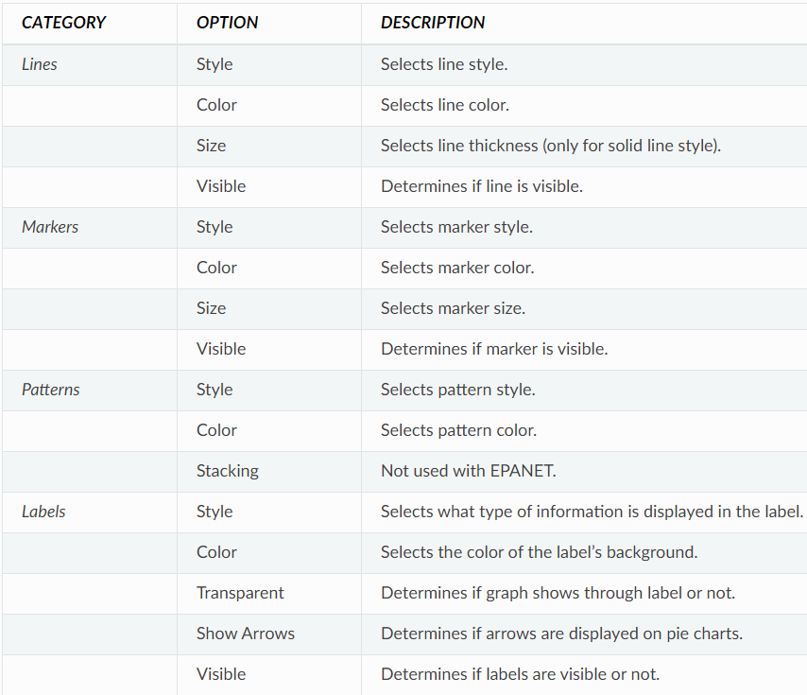

The Contour Options dialog form is used to customize the appearance of a contour graph.

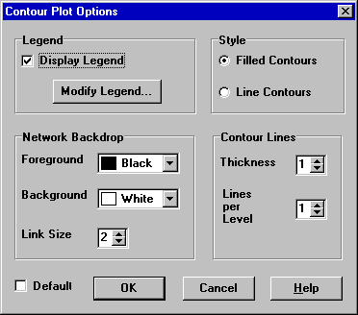

Contour Plot Options Dialog

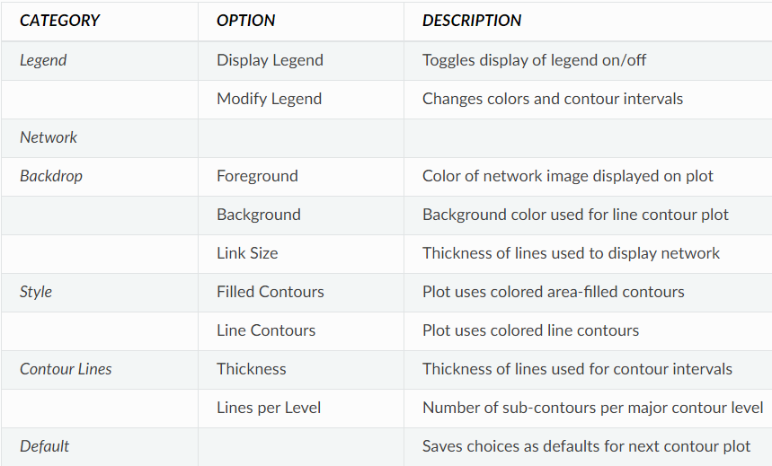

## **Viewing Results with a Table:**

EPANET allows you to view selected project data and analysis results in a tabular format:

* A Network Table lists properties and results for all nodes or links at a specific period of time.
* A Time Series Table lists properties and results for a specific node or link in all time periods.

Tables can be printed, copied to the Windows clipboard, or saved to file.

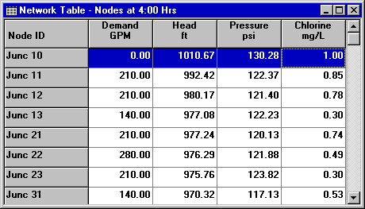

To create a table:

1. Select **View >> Table** or click image127 on the Standard Toolbar.
2. Use the Table Options dialog box that appears to select:
   * The type of table
   * The quantities to display in each column
   * Any filters to apply to the data

The Table Selection options dialog form has three tabs. All three tabs are available when a table is first created. After the table is created, only the Columns and Filters tabs will appear.

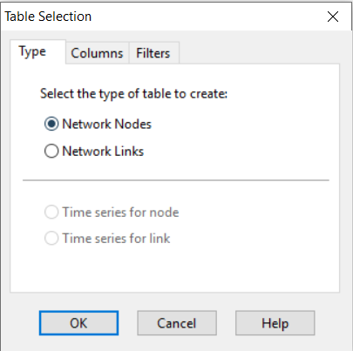

**Type Tab:**

The Type tab of the Table Options dialog is used to select the type of table to create. The choices are:

* All network nodes at a specific time period
* All network links at a specific time period
* All time periods for a specific node
* All time periods for a specific link

Data fields are available for selecting the time period or node/link to which the table applies.

**Columns Tab:**

The Columns tab of the Table Options dialog form selects the parameters that are displayed in the table’s columns.

* Click the checkbox next to the name of each parameter you wish to include in the table.
* To sort a Network-type table with respect to the values of a particular parameter, select the parameter from the list and check off the **Sorted By** box at the bottom of the form. (The sorted parameter does not have to be selected as one of the columns in the table.) Time Series tables cannot be sorted.

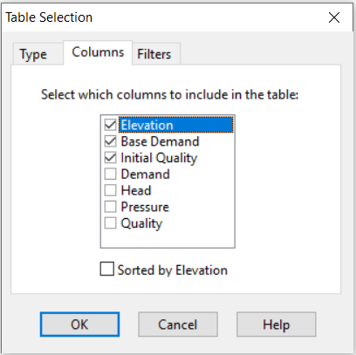

**Filters Tab:**

The Filters tab of the Table Options dialog form is used to define conditions for selecting items to appear in a table. To filter the contents of a table:

* Use the controls at the top of the page to create a condition.
* Click the **Add** button to add the condition to the list.
* Use the **Delete** button to remove a selected condition from the list.

Multiple conditions used to filter the table are connected by AND’s. If a table has been filtered, a re-sizeable panel will appear at the bottom indicating how many items have satisfied the filter conditions.

**Viewing Special Reports:**

In addition to graphs and tables, EPANET can generate several other specialized reports. These include:

* Status Report
* Energy Report
* Calibration Report
* Reaction Report
* Full Report

All of these reports can be printed, copied to a file, or copied to the Windows clipboard (the Full Report can only be saved to file.)

**Status Report:**

EPANET writes all error and warning messages generated during an analysis to a Status Report. Additional information on when network objects change status and a final mass balance accounting for water quality analysis are also written to this report if the Status Report option in the project’s Hydraulics Options was set to Yes or Full. For pressure driven analysis, node demand deficiency will also be reported in the status report. To view a status report on the most recently completed analysis select **Report >> Status** from the main menu.

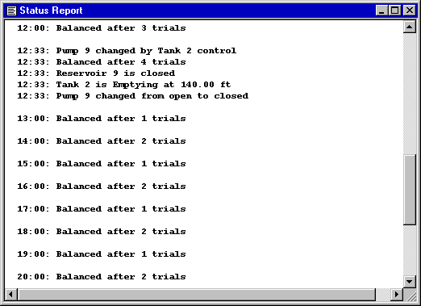

**Energy Report:**

EPANET can generate an Energy Report that displays statistics about the energy consumed by each pump and the cost of this energy usage over the duration of a simulation. To generate an Energy Report, select **Report >> Energy** from the main menu. The report has two tabs, Table and Chart. One displays energy usage by pump in a tabular format. The second compares a selected energy statistic between pumps using a bar chart.

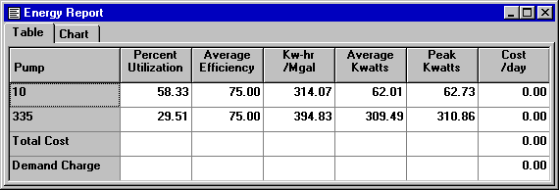

**Calibration Report:**

A Calibration Report can show how well EPANET’s simulated results match measurements taken from the system being modelled. To create a Calibration Report:

1. First make sure that Calibration Data for the quantity being calibrated has been registered with the project.
2. Select **Report >> Calibration** from the main menu.
3. In the Calibration Report Options form that appears:
   * Select a parameter to calibrate against
   * Select the measurement locations to use in the report
4. Click **OK** to create the report.

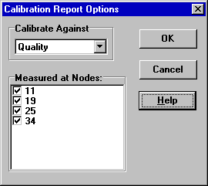

After the report is created the Calibration Report Options form can be recalled to change report options by selecting **Report >> Options** or by clicking image135 on the Standard Toolbar when the report is the current active window in EPANET’s workspace.

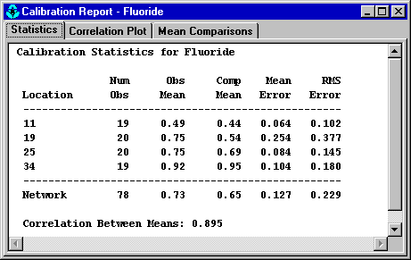

**Statistics Tab:** This lists various error statistics between simulated and observed values at each measurement location and for the network as a whole. If a measured value at a location was taken at a time in-between the simulation’s reporting time interval then a simulated value for that time is found by interpolating between the simulated values at either end of the interval.The statistics listed for each measurement location are:

* Number of observations
* Mean of the observed values
* Mean of the simulated values
* Mean absolute error between each observed and simulated value
* Root mean square error (square root of the mean of the squared errors between the observed and simulated values)

**Correlation Plot Tab:** This displays a scatter plot of the observed and simulated values for each measurement made at each location. Each location is assigned a different colour in the plot. The closer that the points come to the 45-degree angle line on the plot the closer is the match between observed and simulated values.

**Mean Comparisons Tab:** This presents a bar chart that compares the mean observed and mean simulated value for a calibration parameter at each location where measurements were taken.

**Reaction Report:**

A Reaction Report, available when modelling the fate of a reactive water quality constituent, graphically depicts the overall average reaction rates occurring throughout the network in the following locations:

* The bulk flow
* The pipe walls
* Within storage tanks

A pie chart shows what percent of the overall reaction rate is occurring in each location. The chart legend displays the average rates in mass units per hour. A footnote on the chart shows the inflow rate of the reactant into the system.

The information in the Reaction Report can show at a glance what mechanism is responsible for the majority of growth or decay of a substance in the network. For example, if one observes that most of the chlorine decay in a system is occurring in the storage tanks and not at the walls of the pipes then one might infer that a corrective strategy of pipe cleaning and replacement will have little effect in improving chlorine residuals.

A Graph Options dialog box can be called up to modify the appearance of the pie chart by selecting **Report >> Options** or by clicking image138 on the Standard Toolbar, or by right-clicking anywhere on the chart.

**Full Report:**

When the image139 icon appears in the Run Status section of the Status Bar, a report of computed results for all nodes, links and time periods can be saved to file by selecting **Full** from the **Report** menu. This report, which can be viewed or printed outside of EPANET using any text editor or word processor, contains the following information:

* Project title and notes
* A table listing the end nodes, length, and diameter of each link
* A table listing energy usage statistics for each pump
* A pair of tables for each time period listing computed values for each node (demand, head, pressure, and quality) and for each link (flow, velocity, headloss, and status)

This feature is useful mainly for documenting the final results of a network analysis on small to moderately sized networks (full report files for large networks analysed over many time periods can easily consume dozens of megabytes of disk space). The other reporting tools described in this chapter are available for viewing computed results on a more selective basis.